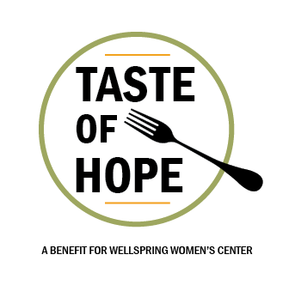
Taste of Hope

A benefit event on April 2, 2020; held at The Mack Powell Event Center, 2003 Howe Avenue, Sacramento, for Wellspring Women’s Center. Wellspring has nurtured the innate goodness and personal self-esteem of women and children since 1987. Sponsorship at any level supports this drop-in center providing respite and services based on “hospitality with dignity and love.”

Sponsorship Support Levels

Champion of Hope Sponsor $10,000 | Hospitality Host Sponsor $5,000
- Two VIP tables  - Logo on all print media  - Acknowledgement and speaking time from podium during event program  - Full page ad in event program  - Printed recognition on table signage  - Recognition in e-newsletter, on social media, and on website  - Ability to place promotional items on display table  - Company logo on tote bag given to all guests | - One VIP table  - Name in all print media  - Acknowledgement from podium during event program  - Full page ad in event program  - Printed recognition on table signage  - Recognition in e-newsletter, on social media, and on website  - Ability to place promotional items on display table  - Company logo on tote bag given to all guests
Journey of Hope Sponsor $2,500 | Taste of Hope Table Sponsor $1,250
- Your Company Logo Sponsoring one Journey Of Hope Tasting Station  - One table with premium seating  - Half page ad in event program  - Printed recognition on table signage | - One event table  - Quarter page ad in event program  - Printed recognition on table signage
Gathering Place Sponsor $500
- Two event tickets
- A business card ad in event program

Sponsor Registration Form

SPONSORSHIP LEVEL (CHOOSE ONE)

- Champion of Hope Presenting Sponsor | $10,000
- Hospitality Host Sponsor | $5,000
- Journey of Hope Sponsor | $2,500
- Taste of Hope Table Sponsor | $1,250
- Gathering Place Sponsor| $500

- I am unable to attend, but would like to make a donation of $_____________to Wellspring Women’s Center.

______________________________________________________________________________
COMPANY NAME CONTACT PHONE

______________________________________________________________________________
STREET ADDRESS CITY/STATE/ZIP

METHOD OF PAYMENT

- Check $______________(Please enclose and make payable to Wellspring Women’s Center, P.O. Box 5728, Sacramento, CA 95817)
- Credit Card
  - Mastercard
  - VISA
  - AMEX
  - Discover

______________________________________________________________________________
NAME ON CARD CARD NUMBER EXP. DATE

Wellspring Women’s Center is a 501 (c)(3) nonprofit organization | FEIN 91-1752615
Your tax deductible contribution is the amount over $35 per attending guest.

QUESTIONS?
Contact Wellspring Women’s Center at 916.454.9688 ext. 207 or genelle@wellspringwomen.org. Respond by March 1, 2020 to receive all sponsorship benefits for your selected level.

